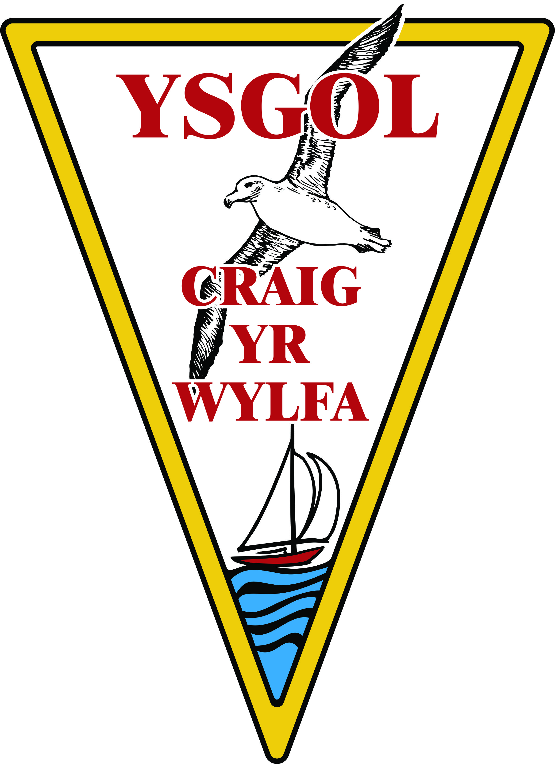
WHOLE SCHOOL FOOD POLICY

Date of policy implementation - January 2014
Date of next review January 2015

The aim of the whole school food policy is to encourage a holistic approach to healthy eating and food and nutrition throughout the school.

Water provision
In line with government recommendations, we will provide drinking water for all of our pupils.
This will be achieved by:-
- Allowing pupils to have drinking bottles in the classroom and allowing access to them at certain times throughout the day
- Allowing pupils to use the conical cups at certain times throughout the day
- Providing jugs of water on lunchtime tables

Dining room environment
We will endeavour to maintain an environment conducive to healthy eating.
This will be achieved by:-
- Using artwork/posters to promote healthy eating in the dining room
- Ensuring each pupil has enough time to eat lunch
- Encouraging children to choose healthy options
- Making time for pupils to wash their hands before eating their lunch
- Ensuring there is adequate provision for litter to be disposed of

Packed lunches
We will consult with LA catering service, parents and pupils to agree on the types and amounts of foods which should be included within packed lunches.
This will be achieved by:-
- Producing a guide to suitable foods that should be included in packed lunches following government recommendations
- Regular contact with parents to discuss new ideas and ensure pupils are enjoying the foods they bring to school

Break time snacks
We discourage crisps, biscuits, chocolate and fizzy drinks as break time snacks and encourage suitable snacks such as fruit, milk and water.
This will be achieved by:-
- Consultation with parents and pupils to discuss suitable break time snacks
- Ensuring crisps, chocolate, biscuits and fizzy drinks are not available on school premises
- Setting up a fruit tuck shop to allow pupils to buy fruit at break times
- Liaising with staff

Breakfast clubs
We will endeavour to serve healthy breakfast foods low in fat, salt and sugar every weekday morning through a breakfast club.
This will be achieved by:-
- Following government recommendations for breakfast foods
- Liaising with Catering Department and breakfast club staff

After school clubs
If snacks are served in after school clubs they will follow the break time snacks policy.
This will be achieved by:-
- Consultation with parents and pupils to discuss suitable after school club snacks
- Ensuring crisps, chocolate, biscuits and fizzy drinks are not available for pupils to buy on school premises
- Liaising with staff

School meals
In line with government recommendations, will we provide healthy, nutritious lunch time foods.
This will be achieved by:-
- Following government recommendations
- Liaising with catering staff

The curriculum
Healthy eating, food and nutrition will be taught to all pupils through various lessons in the curriculum.
This will be achieved by:-
- Teachers including healthy eating, food and nutrition lessons into each subject area
- Reviewing the formal curriculum
- Using artwork/posters/poems/stories to promote healthy eating

Commercial activities in schools
Commercial activities will only be undertaken by the school if they bring sufficient benefit to the school without compromising healthy eating messages.
This will be achieved by:-
- Consultation with providing company to check rules, regulations, advertising, terms and conditions of the scheme
- Consultation with teachers, parents and pupils

Monitoring and Evaluation
The whole school food policy will be monitored and evaluated in the following ways:-
- Looking at curriculum schemes of work.
- Ensuring above contain up to date information regarding healthy eating and food and nutrition
- Weekly menus from breakfast club/school meals service
- Feedback from pupils through questionnaires and/or discussion groups
- Reporting on the numbers using the breakfast club/school meals service
- Ensuring the whole school food policy is discussed in school council meetings and using the minutes for monitoring and evaluation

